**Lab Equipment Reservation Manual**

1. **Logging In**

To access the reservation system, you will need to log in with your credentials:

Username: Your assigned username

Password: Your password

Enter your username and password on the login screen and click the "Login" button. You will be taken to the main dashboard if your login is successful.

1. **Main Dashboard**

Once logged in, you will see the main dashboard that includes several tabs:

* Reservation Tables
* Reservation Forms
* Reservation Cancellation
* Contact Us



1. **Making a Reservation**

To make a reservation:

* Navigate to the Reservation Forms tab.
* Select the room where the equipment is located.
* Choose the equipment you wish to reserve.
* You will see details and an image of the selected equipment if available.
* Select the date and time for your reservation.
  + Note: Booking in advance limits are set based on the equipment. General equipment can be booked up to 1 month in advance for Students and 2 months for lecturers, while Autoclaves and PCR Machines are limited to 1 day in advance.
* After selecting the time, click the "Submit Reservation" button.
* You will receive a confirmation message if the reservation is successful.

1. **Viewing Reservations**

* Go to the Reservation Tables tab.
* You can view your current reservations by selecting the room and viewing the schedule displayed. The system uses a Gantt chart format to show all reservations for the selected room.

1. **Cancelling a Reservation**

* Navigate to the Reservation Cancellation tab.
* You will see a list of your upcoming reservations.
* Select the reservation you wish to cancel and click the "Cancel Reservation" button.
* A confirmation message will appear if the cancellation is successful.

1. **Contact and Report Issues**

* If you encounter any issues or have queries, you can contact the admin through the Contact Us tab.
* Fill out the form with your name, email, and message, then click "Send" to submit your query or report.

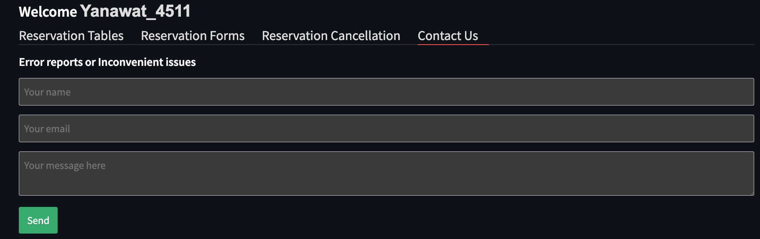

1. **Announcement**

Lecturers and Admins can announce important messages to every user and the message will be rad and moving on the top of the page to make it easy to see. Enter the announcement message and click the ‘Update Announcement’ button.

1. **Download a Reservation Records**

Every user can download the reservation record machines to their local machine by clicking the ‘Download General Reservations as CSV’ button for non-PCR equipment and ‘Download PCR Reservations as CSV’ button for PCR Machines in the sidebar.

1. **Logging Out**

When you are done, you can log out by clicking the "Log Out" button in the sidebar.

